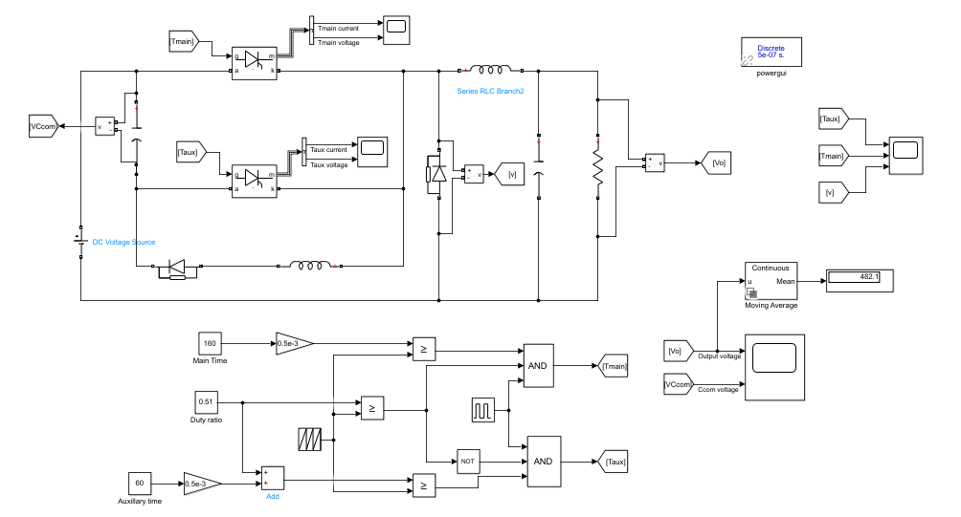

[1] Choose the commutation inductor 𝐿𝑐 in such a way that the peak current through the main thyristor remains at 95 A (±5% is considerable).

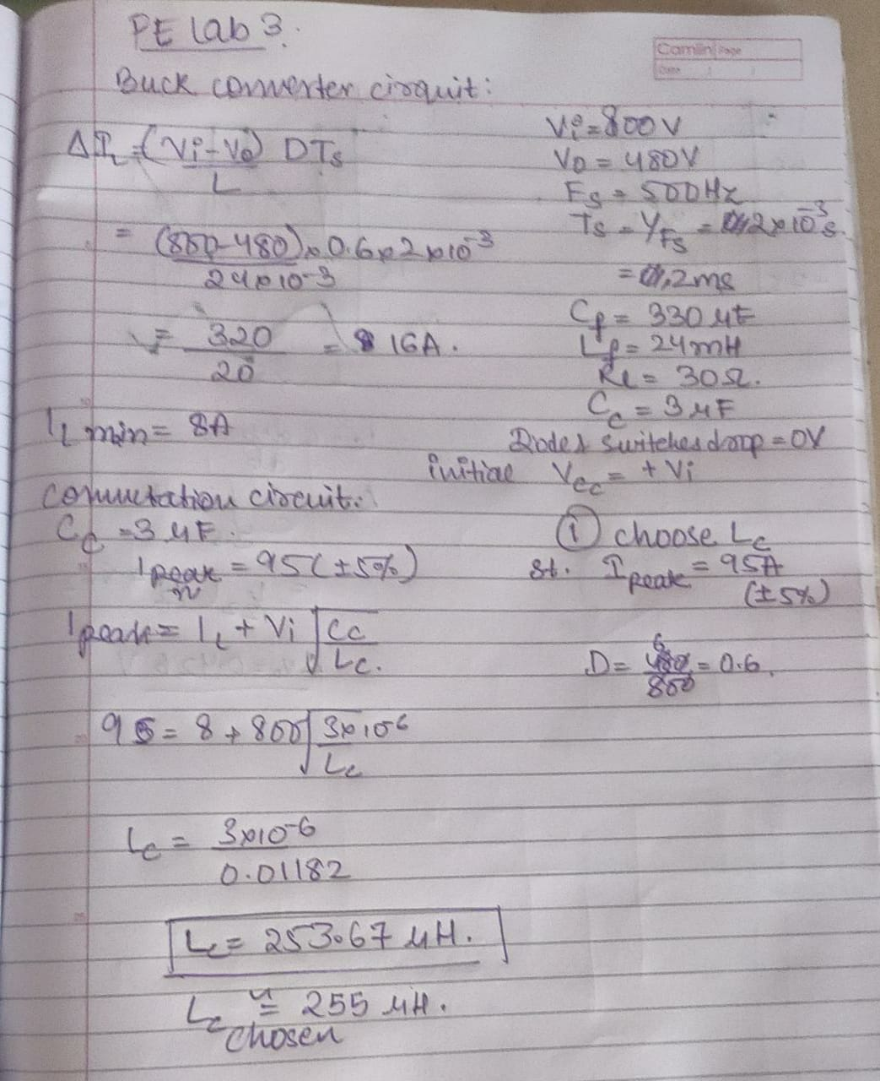

Lc used is ~ 254e-6 H

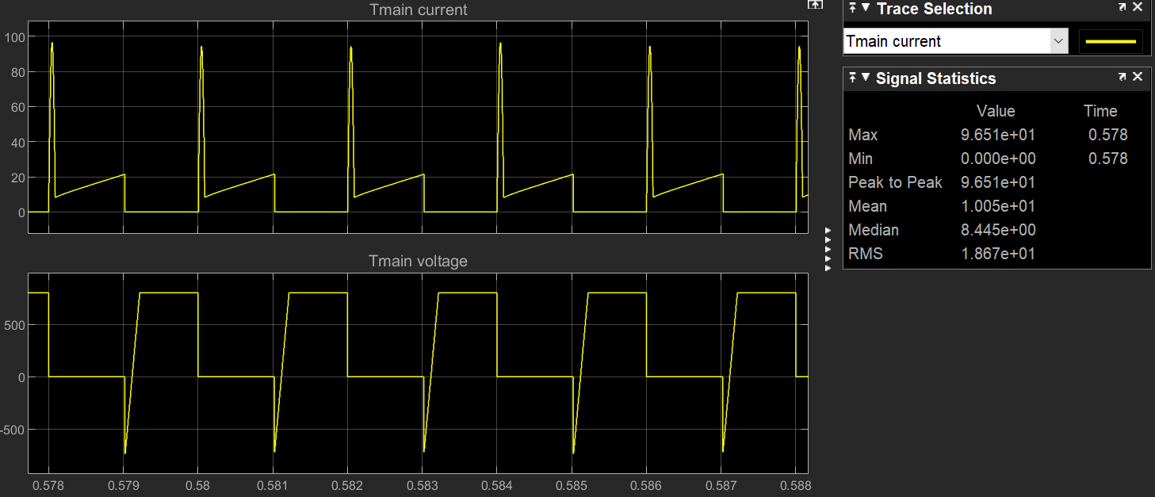

Experimental I main max is 96.7A.

The theory I main max is 95A.

[2]

(i) Note the required turn-on time manipulation to get 480V output voltage.

Experimentally duty ratio value is 0.51

Ton = DxTs = 0.51*2 = 1.02ms

(ii) Note the circuit turn-off time of main & auxiliary thyristors.

MAIN:

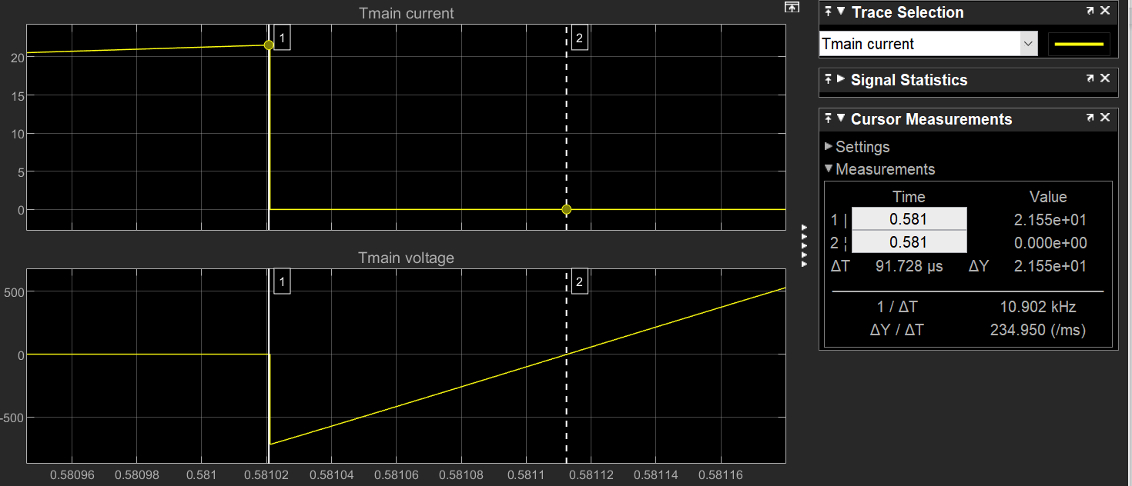

Toff = 0.0917ms

AUXILLIARY:

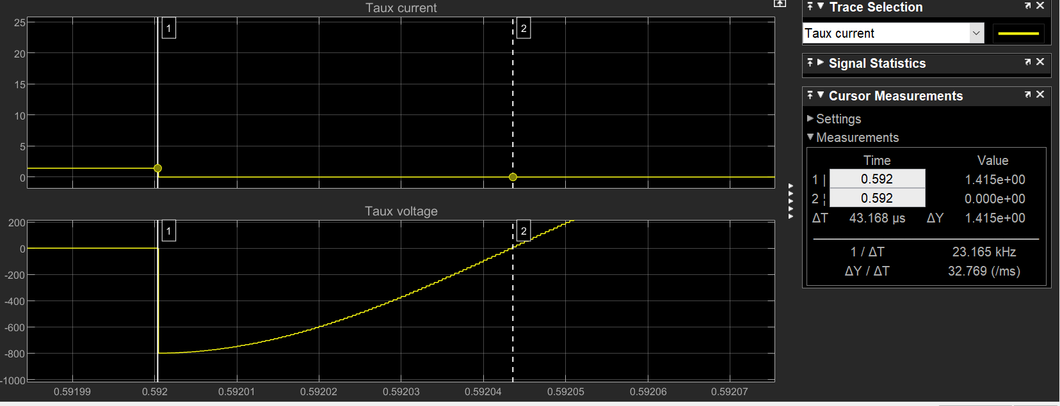

Toff = 0.043ms

(iii)

Voltage across Cc

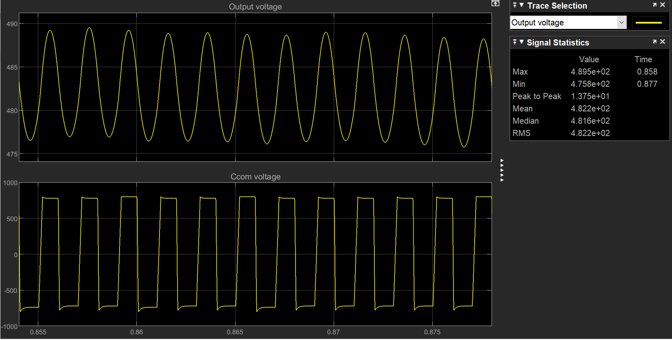

(iv) Commutation failure of the main thyristor happens at Cc=77.5 nF approximately.

| Cc=3 micro F |  |
| --- | --- |
| Cc=0.1 micro F |  |
| Cc=80 nF |  |
| Cc=77.5 nF |  |
| Cc=75 nF |  |